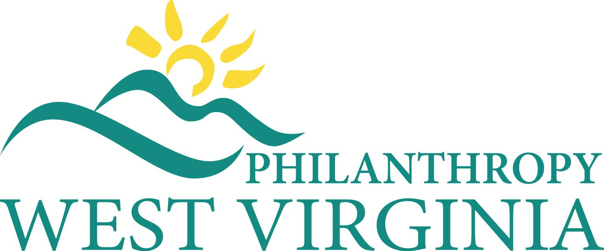

MEDIA RELEASE

The Mountain State Celebrates Community Foundations Week

Contact: Paul D. Daugherty, President & CEO: 304.517.1450 (O)
paul@philanthropywv.org

Celebrating the impact of philanthropy and advancing its work is the focus of the 2020 Community Foundations Week and National Philanthropy Day this month in West Virginia. West Virginia Governor James Justice declared November 15 – 21st, 2020 Community Foundations Week. For more than fifty-five years, community foundations make it possible for West Virginia citizens, businesses, and organizations to create permanent philanthropic resources for the current and future needs of our communities from basic human needs to creating innovative solutions that transform our towns, cities and counties.

“The (insert your community foundation name here) provides the democratic opportunity for individuals from all walks of life to be philanthropists in small, medium, and large ways. West Virginia has over 30 community foundations, affiliates, and area funds around the Mountain State serving fifty two of our state’s fifty five counties,” shares (your CF leader name here), (title of your CF leader) of (your community foundation name here).

One of the greatest ways to ensure a strong community, economic vitality, educational success, and effective community leadership is through the active presence of a community foundation that allows for local community-based endowments. These endowments provide permanent philanthropic resources that build stronger West Virginia communities and improve the quality of life for all citizens.

Our community foundation, (insert CF name here) is celebrating WV Community Foundations Week by (insert the program/event you are hosting). (Examples: Participating in a statewide social media challenge by promoting their work and increasing their followers on Facebook and/or Twitter to get a major marketing grant.)

“We celebrate the generosity of our donors and the impact our foundation with their giving makes an impact on improving our community’s quality of life. We invite our neighbors in (insert foundation’s county here) join us in our celebrations this week,” noted (insert your CF leader’s name here).. With the year-end fast approaching, it’s a tremendous time for citizens to make an investment to advance their communities by supporting their local community foundation. For more details on the (insert your CF name here), visit: (insert your web address here).

